# Calisthenics & Flexibility Program

By Me (El Messari Yassine)

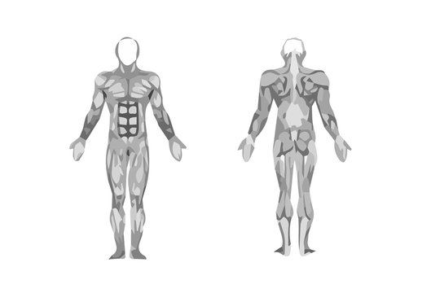

# **Summary**

1. **Introduction & Body Map 3****- Introduction 3****- Muscle Map** **3**
2. **Flexibility 6**

**- Beginner Exercises** **6**

1. **Calisthenics 7**

# **Introduction & Body Map**

## **1.1 Introduction**

Up to now, I’ve never given importance to my body. I had more interests in science subjects, watching videos and whatever stimulates my mind. Now, I want to see myself fit and having a great athletic body. To achieve it, I absolutely need a program. They are some good paid ones, but I’m a minor. So, to learn and to practice at the same time, I’m going to make my own. I’ll do all the searches and I’ll write here what I find interesting. It is going to be hard, long, even stupid you might say, but I need to take this path.   
Each of chapter about Flexibility and chapter about Calisthenics will include a small intro, then exercises, going crescendo in difficulty.

## **1.2 Muscle Map**

Another great idea will be learning the muscle map along the journey, in order to understand more what I’m doing. They are 600. We won’t cover them all, but the most important ones.

First, let’s know more about muscles:

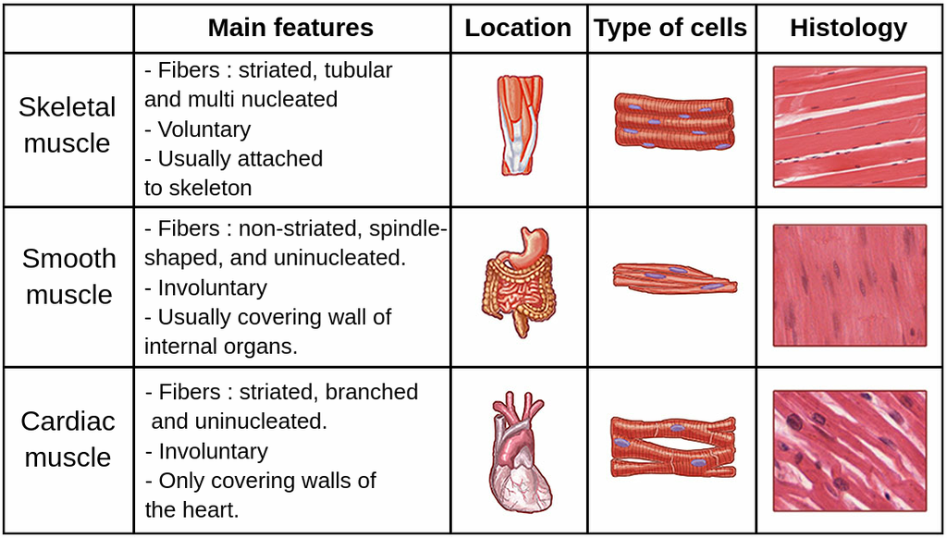

From the descriptions, you can deduce that the muscles that are being part of a workout are the skeletal muscles.

The most common muscles that are being trained during a workout are these: (for an athlete)

*○ Core Muscles:*

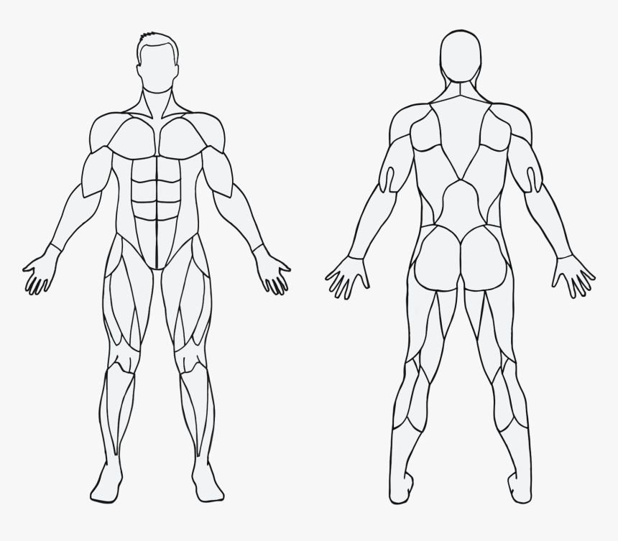

Rectus abdominis (abs)

Obliques

Erector spinae

The core is used to stabilize the thorax and the pelvis during dynamic movement and it also provides internal pressure to expel substances (vomit, feces, carbon-laden air, etc.). A strong core is crucial for stability, balance, and efficient power transfer between the upper and lower body.



Quadriceps

Calves

Hamstrings

*○ Leg Muscles:*

Quadricepsareessential for running, jumping, and squatting movements, hamstrings are important for sprinting, jumping, and preventing knee injuries, calves are vital for running, jumping and maintaining balance.

*○ Back Muscles:*



Latissimus Dorsi

Trapezius

Latissimus Dorsi: Important for upper body strength and activities that involve pulling motions. Trapezius and Rhomboids: Crucial for shoulder stability and posture.



Biceps

Triceps

*○ Arm Muscles:*

Biceps: Important for pulling movements., triceps: Crucial for pushing movements and overall arm strength.

# **Flexibility**

Flexibility enhances your overall athletic performance and quality of life. It helps you move more efficiently, reduces the risk of injuries, and allows for a greater range of motion in your joints. Whether you're an athlete aiming to improve your game or someone who enjoys an active lifestyle, incorporating regular stretching and mobility exercises into your routine can make everyday movements easier and more comfortable. Plus, the relaxation and stress relief that often come with flexibility exercises can improve your mental well-being.

## **Exercises**

### *Stretches*

|  |  |  |
| --- | --- | --- |
| VIDEO) ▶️ Lumbo-pelvic rotation stretch: supine – exer-pediaLumbar Rotation | Hamstring  Supine Hamstring Stretch | Piriformis  Piriformis Stretch, Supine |
| How to Perform the Half-Kneeling Hip Flexor Stretch CorrectlyHip Flexor | Kneeling Hamstring | Spine Conditioning Program - OrthoInfo - AAOSSeated Spine Rotation |
| Child’s Pose  children drawing tutorial how to draw animated humans, illustration of  stretching exercise based on circles arc curved lines Stock Illustration |  Adobe Stock | Upper Back Extension  VIDEO) ▶️ Upper thoracic extension over roll – exer-pedia | Upper Trapezius - Active Sports & Family Chiropractic of Grants Pass, OregonUpper trap |

# **Calisthenics**

Calisthenics is a form of exercise that uses a person's body weight and requires little to no equipment. Examples of calisthenic exercises include pushups, crunches, and burpees. There are many health benefits to calisthenics, and most people can start exercising right away, just at their houses. “Mastering” it really gives you the impression that you’re taking profit of all your body members, coordinating them perfectly, and it gives you that shot of adrenaline and sense of accomplishment.

## **Exercises**

|  |  |  |  |
| --- | --- | --- | --- |
| Strengthening: Wall Push-UpWall Push-up | Incline Push-up | Push-Up: Modified - ResistedKneeling Push-up | Premium Vector | Young athletic man doing push ups hand drawn style vector  illustrationThe Push-up |
| Push-Ups – Their history, Beneficial Effects, Types and Potential Risks -  Physical Culture StudyClose Grip Push-up | Top 3 Push up Variations for Shoulder Mass and Strength — Marks.fitnessDecline Push-up | Sport man do decline push ups Royalty Free Vector ImageDecline Close Grip Push-up | 9 Push-Ups to Get StrongerWide Grip Push-up |
| UntitledUneven Push-up | One Handed Push-up  Push-Ups Guide | Headstand | Sivananda London | Classical YogaHeadstand | Continuous one-line drawing man doing plank exercise. Fitness activity  concept. Single line drawing design graphic vector illustration 21869775  Vector Art at VecteezyPlank |

### *Upper Body Pushing Exercises: (Chest, anterior shoulders, medial shoulders, triceps)*